**How to install Apache Tomcat on Linux machine**

1. Create tomcat user and group with following command.   
   (a) “sudo groupadd tomcat”

(b) “sudo useradd -s /bin/false -g tomcat -d /opt/tomcat tomcat”

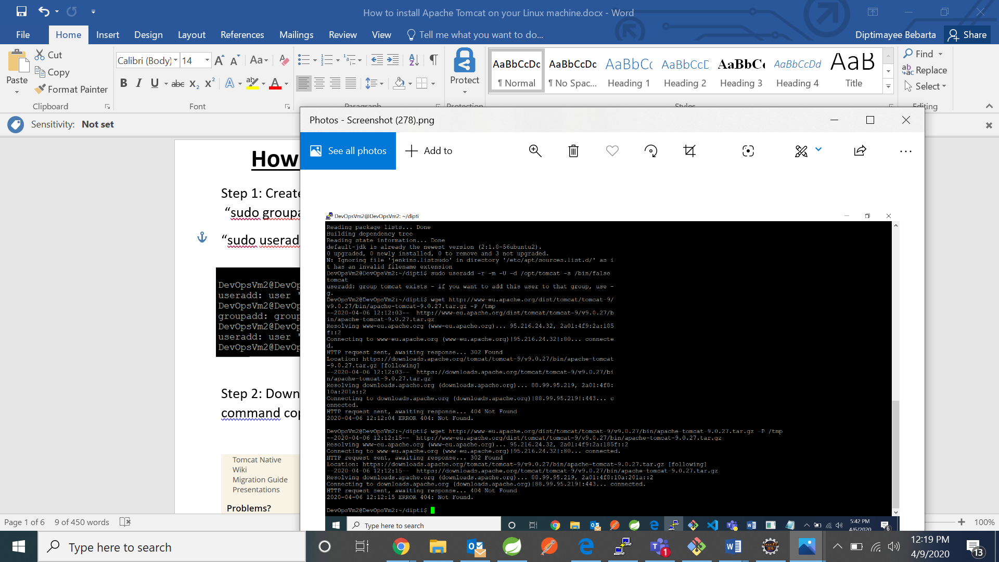

1. Download tomcat version you want by going on apache tomcat website and use curl command copy the tar.gz link

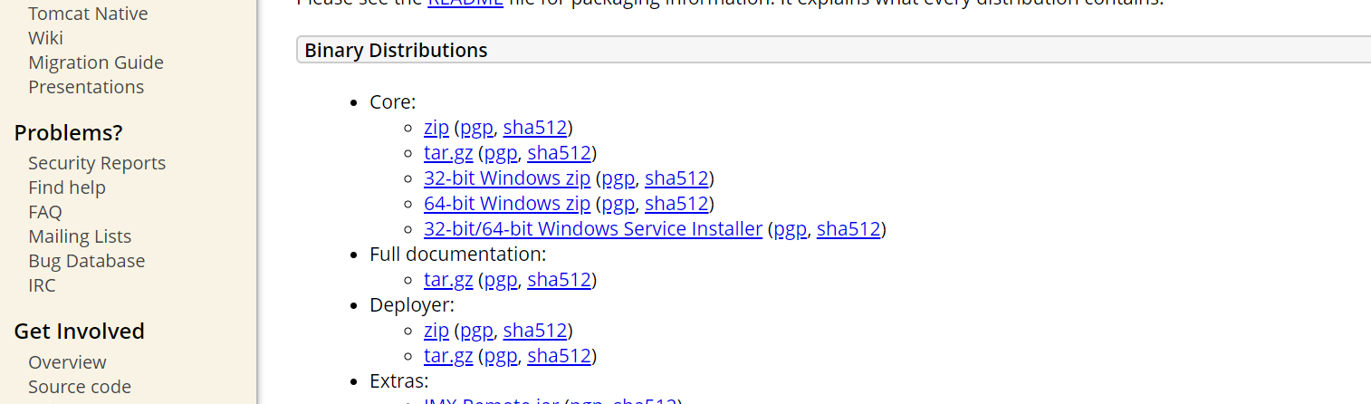

Go back to terminal and change the directory to “cd /tmp” and download the tar.gz hereby using curl command

“curl –O <http://apachemirror.wuchna.com/tomcat/tomcat-8/v8.5.53/bin/apache-tomcat-8.5.53.tar.gz>”

1. To extract the tar.gz Tomcat file, create a new /opt/tomcat/ directory with the command:
2. “sudo mkdir /opt/tomcat”

1. Then, extract the file in the new directory with the following command:

“sudo tar xzvf apache-tomcat-9*tar.gz -C /opt/tomcat --strip-components=1”

It will extracted to /opt/tomcat directory which can be seen by using “cd

/opt/tomcat” command

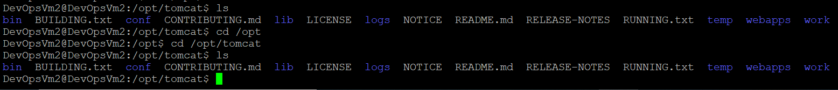

1. Modify Tomcat User Permission
2. Move to the directory where the Tomcat installation is located using “cd /opt/tomcat”
3. Grant group ownership over the installation directory to the tomcat group with the command: “sudo chgrp –R tomcat /opt/tomcat”
4. Give it read access to the conf directory and its contents by using command:“sudo chmod –R g+r conf”
5. Change directory permissions to grant execute access with command:“sudo chmod g+x conf”
6. Give the tomcat user ownership of the webapps, work, temp, and logs directories using the command: “sudo chown –R tomcat webapps/ work temp/ logs”

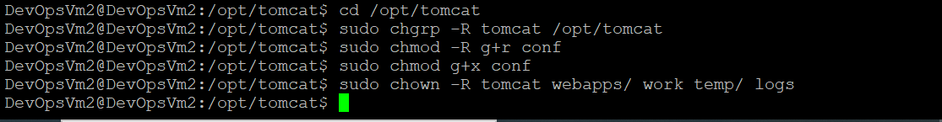

1. Create System unit file

To configure the file, you first need to find the “JAVA_HOME” path. This is the exact location of the Java installation package.

To do so, prompt the system to give you information about the Java packages installed on the system. In the terminal, type:

“sudo update-java-alternatives -l”

1. Create a systemd service file

As the output shows, there are two available versions of Java. Accordingly, it also shows two paths displaying their location.

Choose the version you want to use and copy its location. With that, you can move on to create the service file.

2. Create and open a new file in the /etc/system/system under the name tomcat.service:

“sudo nano /etc/systemd/system/tomcat.service”

3. Once the file opens, copy and paste the content below, changing the JAVA_HOME value to the information you found in the previous step.

[Unit]

Description=Apache Tomcat Web Application Container

After=network.target

[Service]

Type=forking

Environment=JAVA_HOME=/usr/lib/jvm/java-1.11.0-openjdk-amd64

Environment=CATALINA_PID=/opt/tomcat/latest/temp/tomcat.pid

Environment=CATALINA_HOME=/opt/tomcat

Environment=CATALINA_BASE=/opt/tomcat

Environment=’CATALINA_OPTS=-Xms512M –Xmx1024M –server –XX:+UserParallelGC’

Environment=’JAVA_OPTS=-Djava.awt.headless=true Djava.security.egd=file:/dev/./urandom’

ExecStart=/opt/tomcat/bin/startup.sh

ExecStop=/opt/tomcat/bin/shutdown.sh

User=tomcat

Group=tomcat

RestartSec=10

Restart=always

[Install]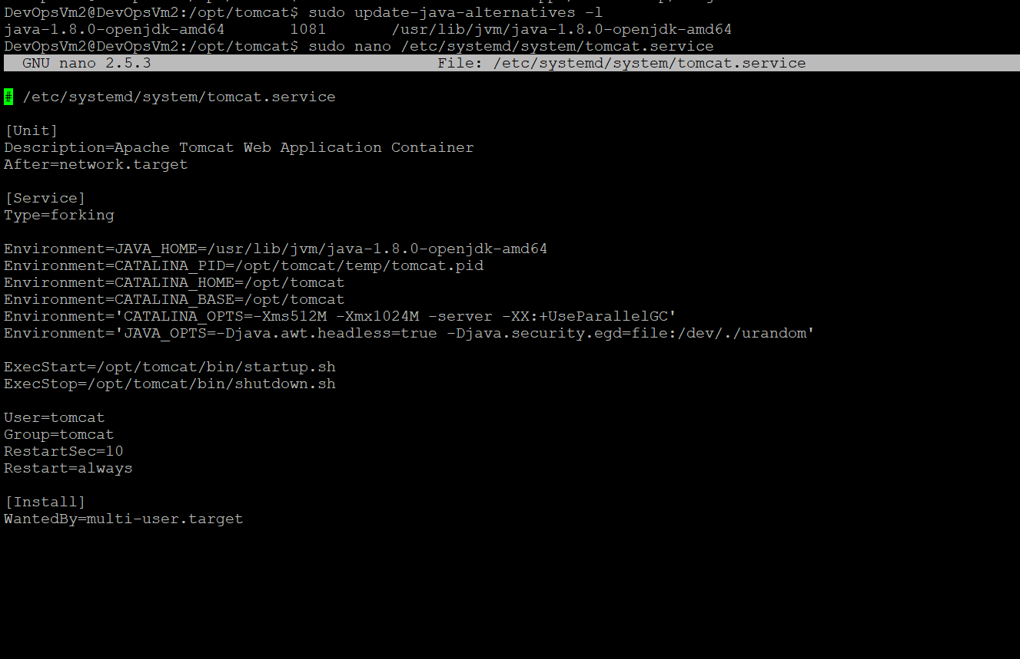WantedBy=multi-user.target

Change Java-Home value.

Save and Exit the file (Ctrl+X, followed by y[es] and Enter).

For the changes to take place, reload the system daemon with the command:

“sudo systemctl daemon-reload”

Now, you can finally start the Tomcat service:

“sudo systemctl start tomcat”

Verify the Apache Tomcat service is running with the command:

“sudo systemctl status tomcat”

The message you want to receive is that the service is active (running).

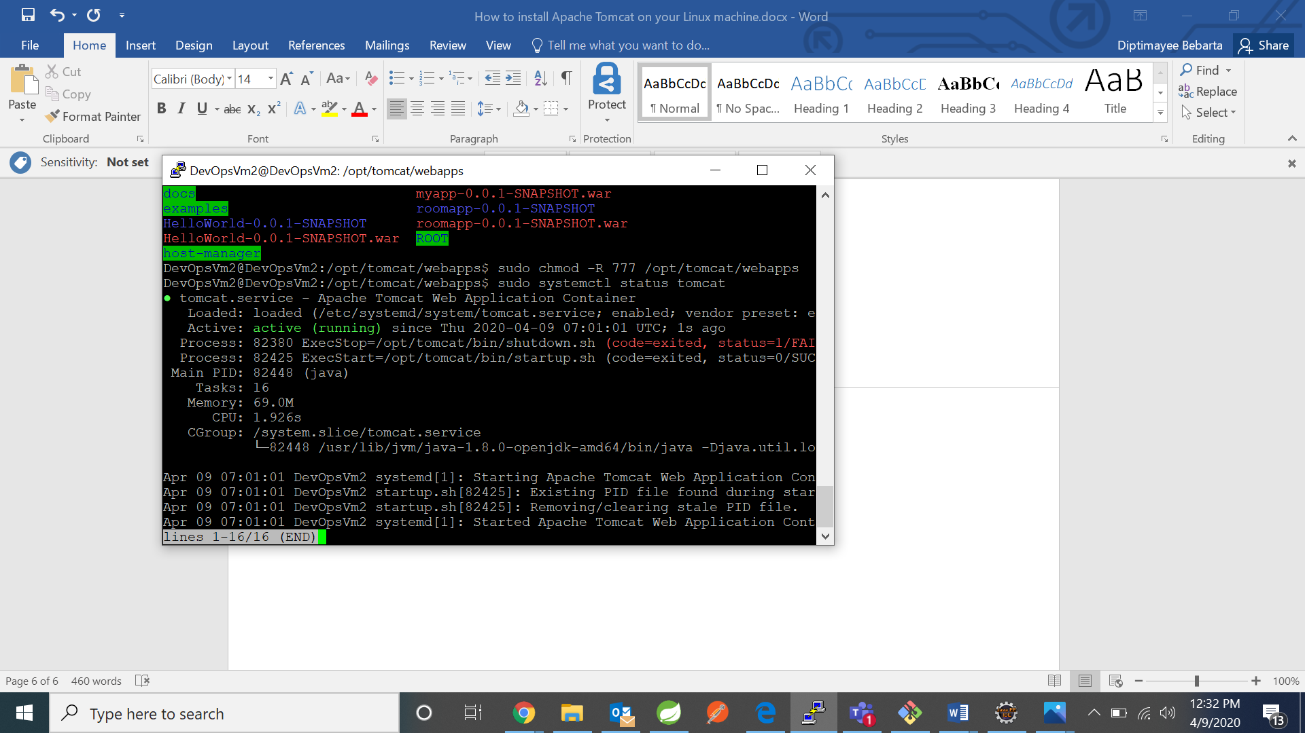

[Unit]

Description=Apache Tomcat Web Application Container

After=network.target

[Service]

Type=forking

Environment=JAVA_HOME=/usr/lib/jvm/java-1.8.0-openjdk-amd64

Environment=CATALINA_PID=/opt/tomcat/temp/tomcat.pid

Environment=CATALINA_HOME=/opt/tomcat

Environment=CATALINA_BASE=/opt/tomcat

Environment='CATALINA_OPTS=-Xms512M -Xmx1024M -server -XX:+UseParallelGC'

Environment='JAVA_OPTS=-Djava.awt.headless=true -Djava.security.egd=file:/dev/./urandom'

ExecStart=/opt/tomcat/bin/startup.sh

ExecStop=/opt/tomcat/bin/shutdown.sh

User=tomcat

Group=tomcat

UMask=0007

RestartSec=10

Restart=always

[Install]

WantedBy=multi-user.target

sudo systemctl list-units --type=service